Evaluate the correctness of blood sugar test using earlobe dataset with Linear regression(jupyter)

[1] I take most of the code from eman azaizeh then I modify some things in code .

[2] Reformulate the dataset to excel file..



[3] Make tow linear model.

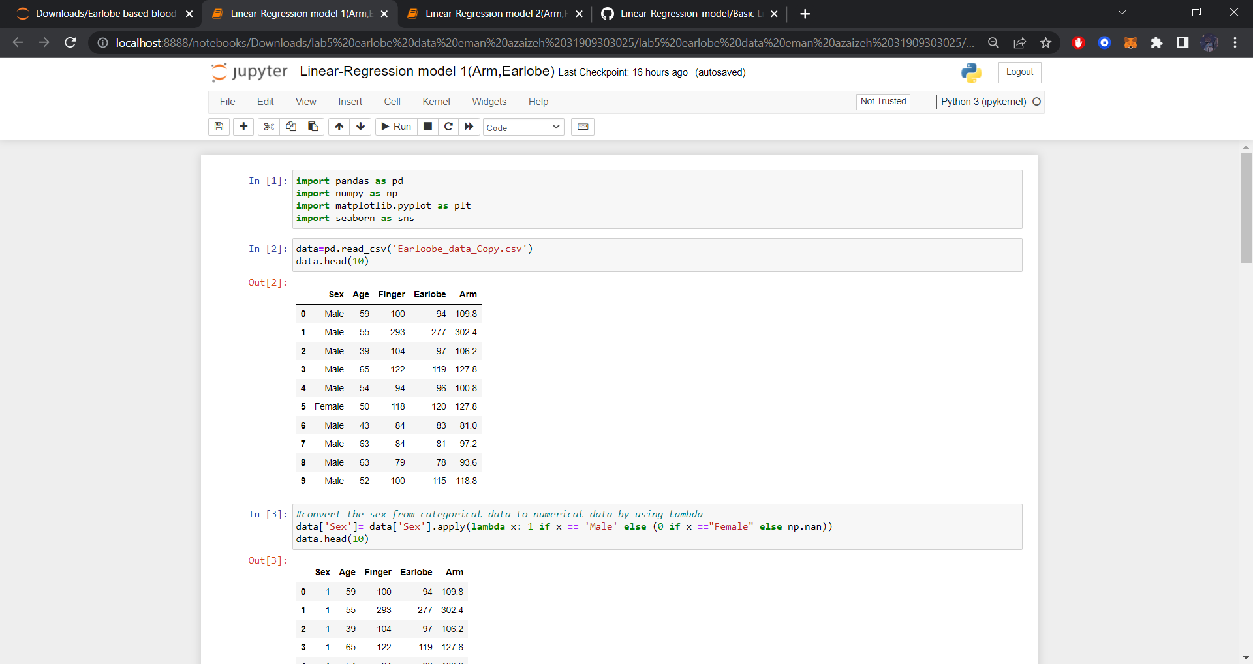

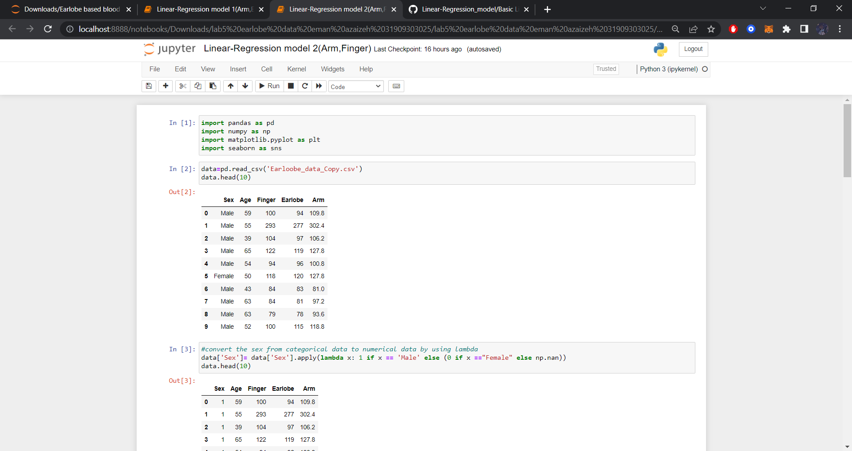

[4] Modify this line of code between " " to the name of my file .csv name (data = pd.read_csv("Earloobe_data_Copy.csv"))

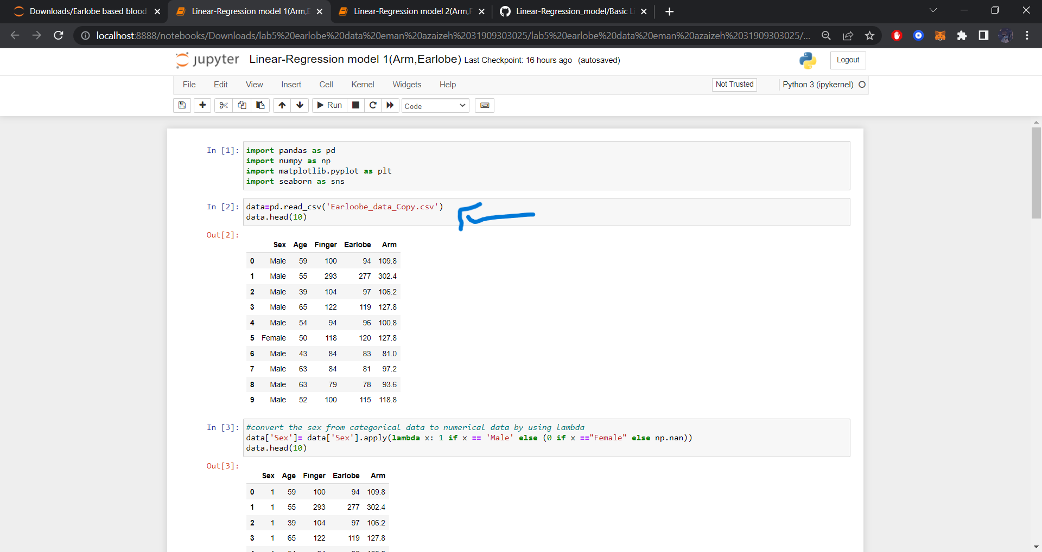

[5] Modify another thing in code to fit with lables in dataset.

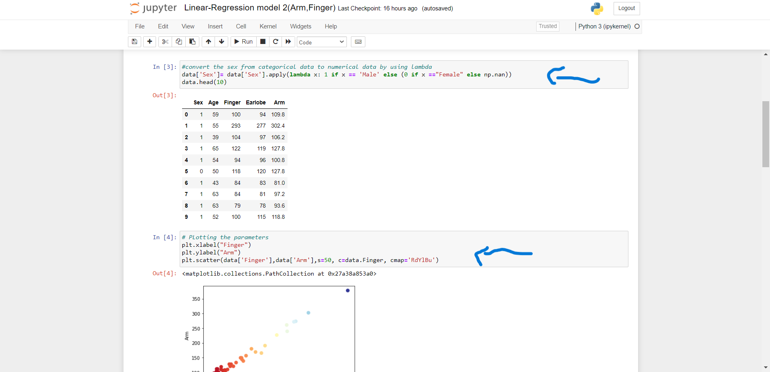

[6]Run the code!

Model1(Arm,Earlobe)..

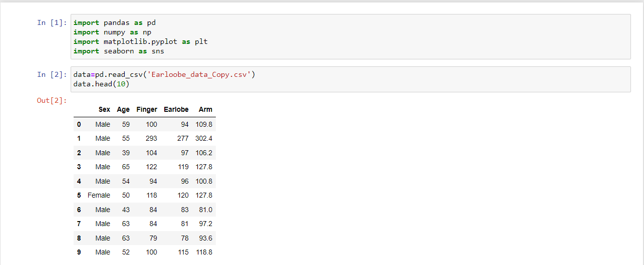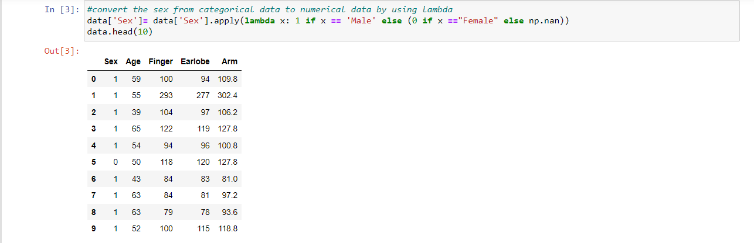

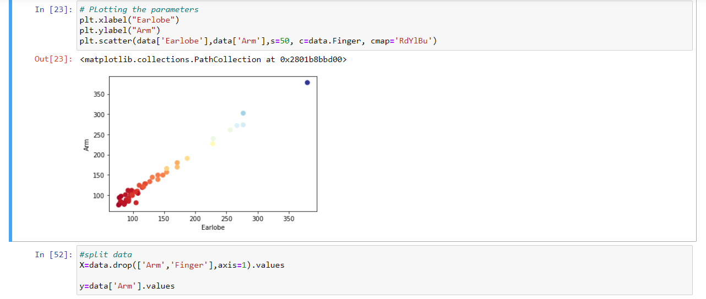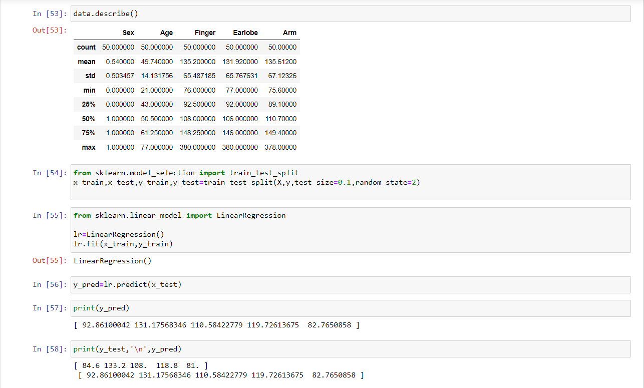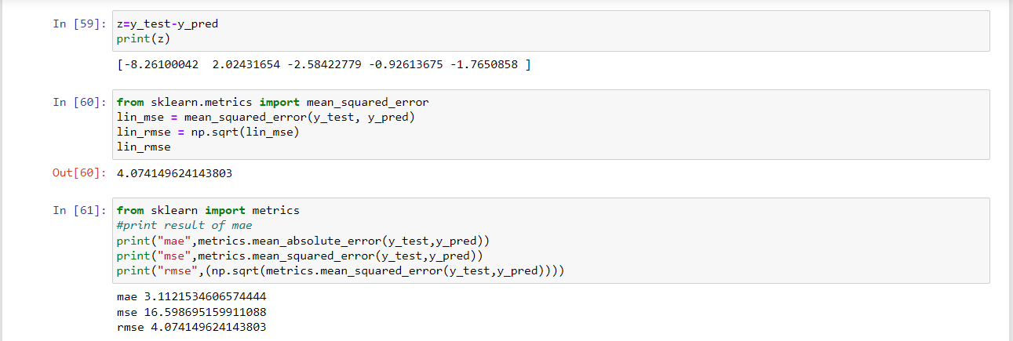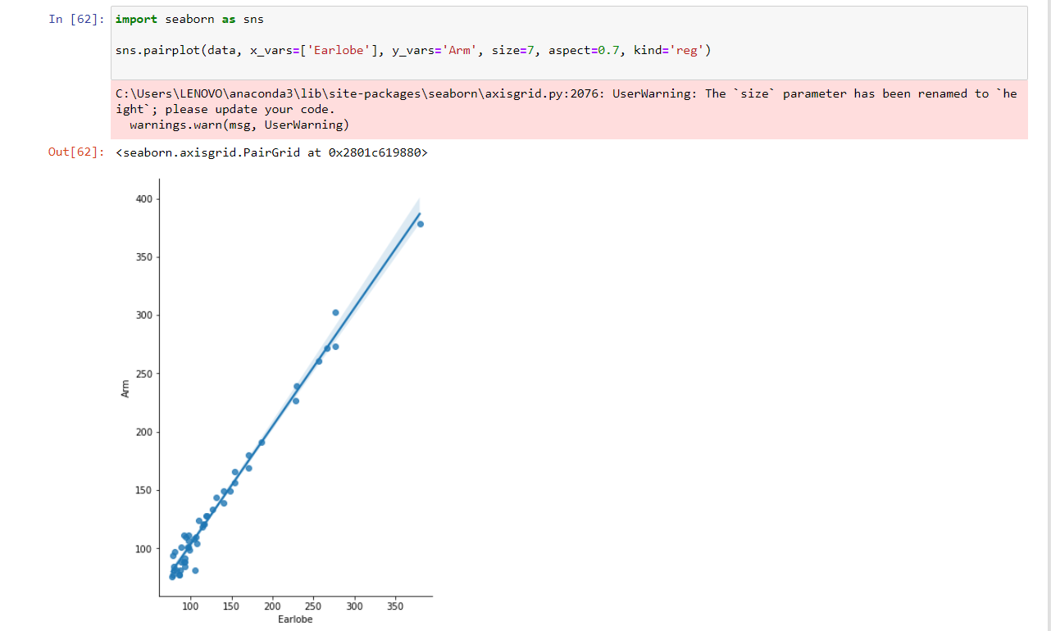

Model2(Arm,Finger)..

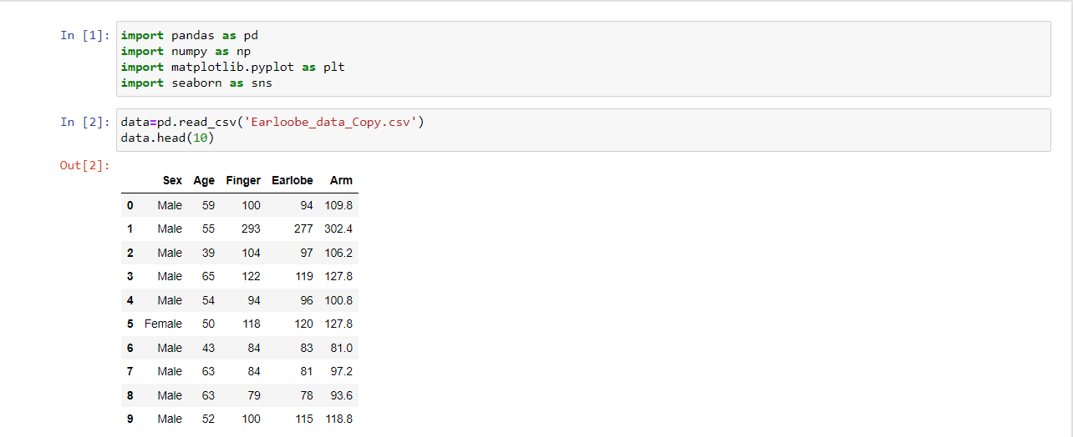

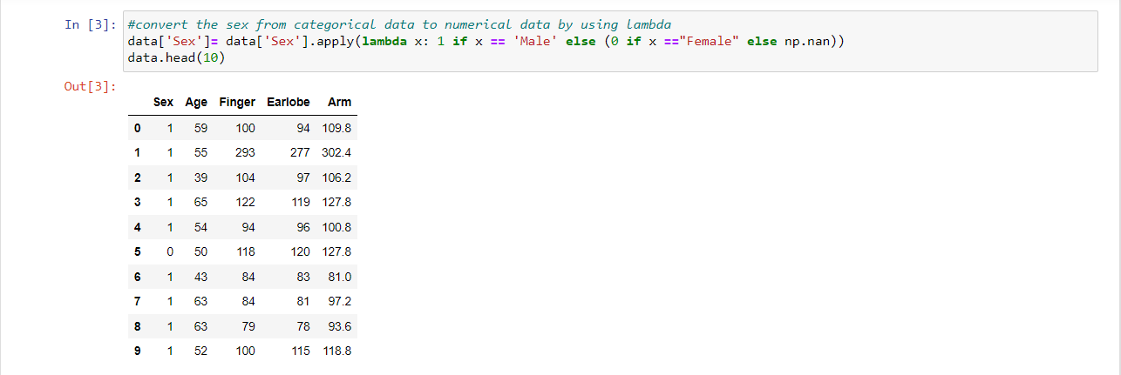

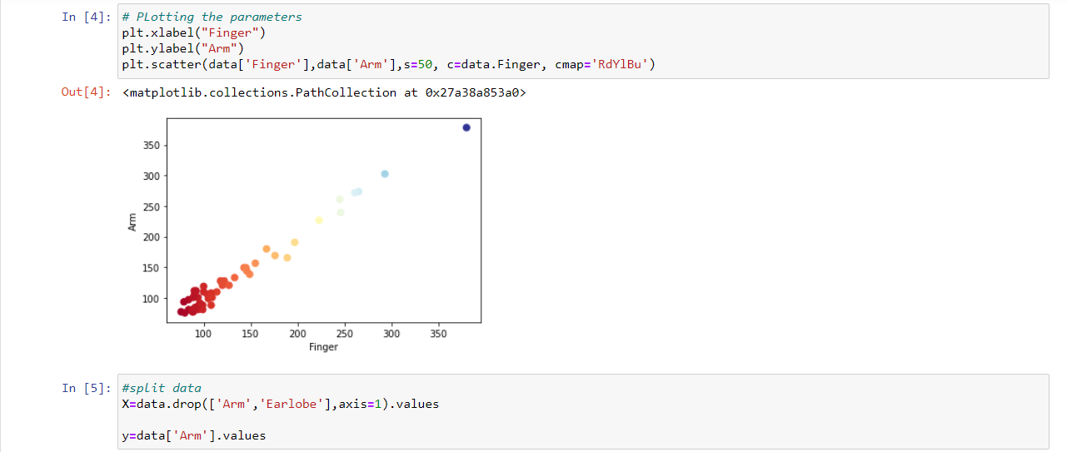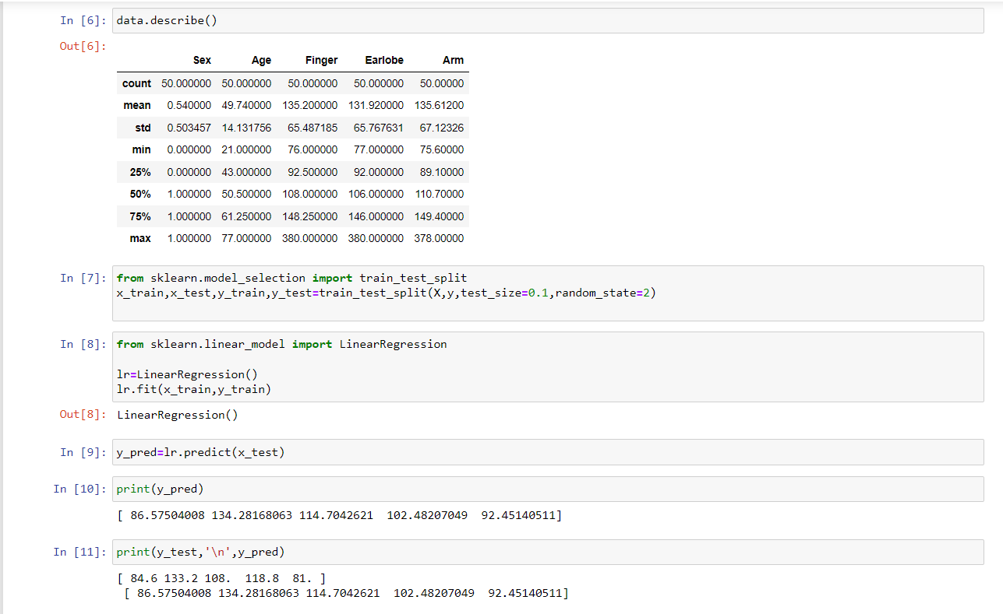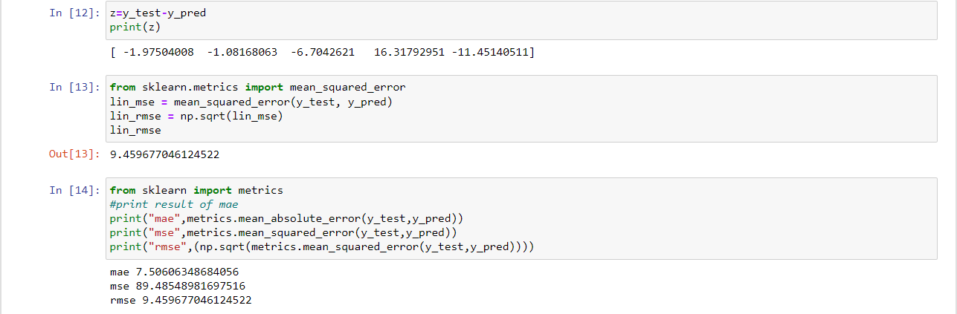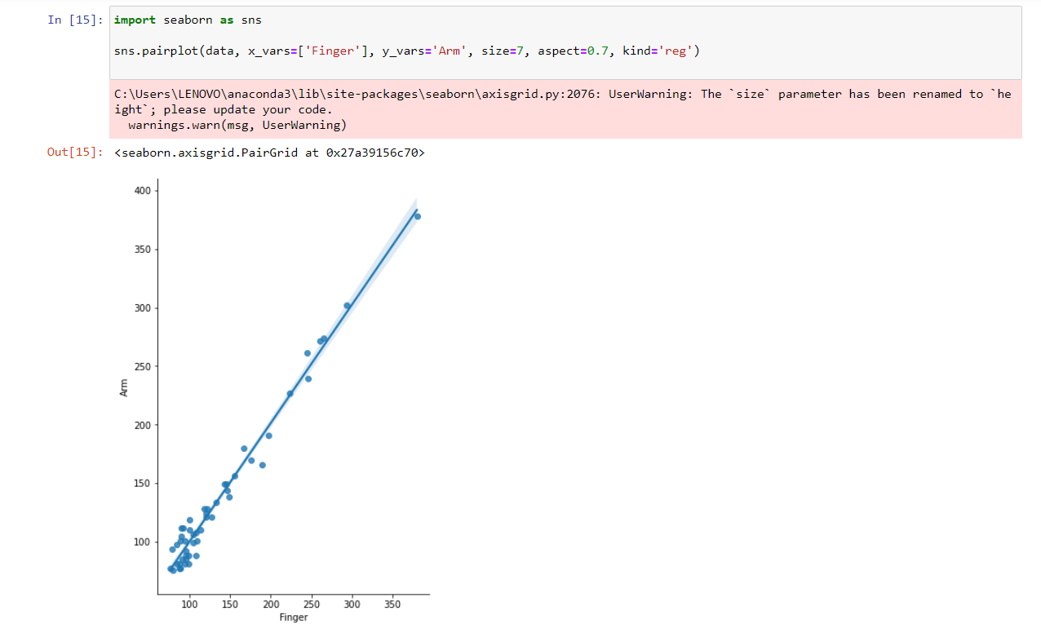

[7] In the first model I evaluate Arm with Earlobe,and By using Ordinary Least Mean Square Method I got these results :

Root Mean Squared Error = [4.074149624143803]

mae 3.1121534606574444

mse 16.598695159911088

rmse 4.074149624143803

[8] in the second model I evaluate Arm with Finger,and By using Ordinary Least Mean Square Method I got these results :

Root Mean Squared Error = [9.459677046124522]

mae 7.50606348684056

mse 89.48548981697516

rmse 9.459677046124522

[9] By comparing the performance of the first and second model, the first model is better than second model So the earlobe test more accurate than finger test referring to Arm test.

### Name : Ramah hashem madi

### ID no. : 31909303044